GIT Commands

To config username : git config - -global user.name “<name>”

To config email : git config - -global user. email “<emailid>”

To start new repository : git init <name>

To obtain repository from existing url : git clone <url>

To add file in staging area : git add <file>

To remove a file from staging area : git reset <file>

To view the changes in code : git diff

To commit the changes : git commit – m “<message>”

: git commit - - amend - -m “msg”

List of files to be committed : git status

To delete a file : git rm <filename>

To create a new branch : git branch <branch name>

To move to another branch : git checkout

To merge the branches : git merge <branch name>

To push a branch to remote repository : git push -u origin branchname

To push the changes : git push <repository>

git push origin master

To pull from repository : git pull <repository link>

To save all modified track files : git stash save “message”

To restore stashed files : git stash pop

To discard stashed files : git stash drop

To merge the branch into master checkout to the master and give the command **git merge branchname**

To check all the branches which are merged : git branch - -merged

To delete a branch locally : git branch - -d branchname

To delete a remote branch : git push origin - -delete bname

Jenkins

* To fetch a repository from GitHub

git clone <url>

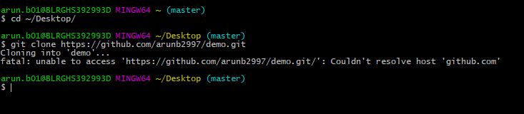

* Crete a job in Jenkins

New item 🡪 Freestyle Project 🡪SCM 🡪 Git

* Give the url of the repository
* In build trigger choose poll SCM and schedule it
* Build 🡪 Choose windows batch command 🡪

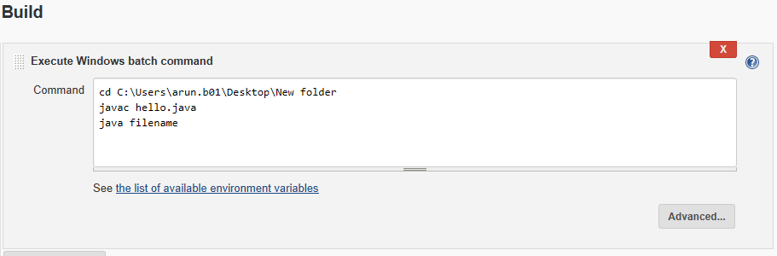

* Save and click ok
* Goto command prompt and change the working directory into the folder we want to upload to git
* Git init
* Git add .
* Git commit –m “Added files”
* Git remote add origin <url of repository>
* Git push –u origin master

So every time we push something into the git the build is triggered and the code is run

Groovy

Keywords: Supports all Java Keywords and some other keywords like def , as

String Interpolation: Placeholder Expression is surrounded by ${} or prefixed with $

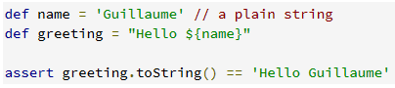

Relational, Logical and Bitwise operators are same as Java

Range Operator : 1 . .10, 1 . .<10

Find Operator : = ~ The return type is a matcher

Match Operator : = = ~ The return type is Boolean

Spread Operator : *.

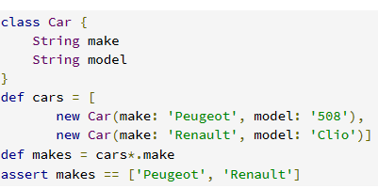

Spread Map Operator : *:

Def m1 = [ 1:a , 2:b ]

Def m2 = [3:c , *:m1 ]

Output m2 = [ 3:c , 1:a , 2:b ]

Method Pointer Operator : .&

Used to store the reference of a method into a variable

def str = 'example of method reference'

def fun = str.&toUpperCase

def upper = fun()

assert upper == str.toUpperCase()

Spaceship Operator : < == > Works as compare and return 0,1, -1

Docker Commands

Docker images : List of images

Docker images –q : Gives image id

Docker images –a : Gives all details of image

Docker pull <image name> : To pull the docker image from repository

Docker push <image name> : To push the docker image to repository

Docker rmi <image id> : To remove one or more images

Docker ps : List all the containers

Docker create : Create a new container

Docker run - it <image name> : run the container

Docker start : to start the container

Docker stop : to stop the container

Docker system prune : Remove all stopped containers & dangling images

Docker Build : Build an image from Dockerfile

Docker containers : Manage Containers

Docker kill : Kill a running docker container